Unit 3 Assignment 1
Audience / Purpose
The audience for the digital portfolio (website) is potential future employers or as an example of skill for a future course interview. These potential employers are going to want to see a demonstration of my skills, abilities and past work from for example BTEC ICT and this is what the digital portfolio (website) will contain. The purpose is as stated above to show off and demonstrate my personal skills / abilities through the use of creating a website to showcase past work (creating the website is an example of skill in itself). To put into context the purpose is to create a website featuring my BTEC ICT work to show off my skills to a company called ‘konnekted’ who is the audience.
Project plan/timeline
Start Date (month) | Actions | What's involved | Time (estimated)
design phase 30/6/14 – 12/9/14
1st July 2014 | Write about audience and intended purpose. | Identify and describe in detail the target audience and the purpose of the digital portfolio. | 1
3rd July 2014 – 4th July 2014 | Create the timeline for the project. | Create a timeline to plan the design, creation and review phase of the unit. It covers all of the assignments in unit 3. | 2
7th July 2014 – 14th July 2014 | Designing and creating storyboards/wireframes. | Design the layout for each page in the digital portfolio and create a wireframe for them. Annotate each of them with what colours, fonts and assets are used. | 4
17th July 2014 | Create a detailed structure chart. | Create a detailed structure chart indicating full and complete navigation routes between all of the pages in the portfolio. | 1
18th July 2014 | Create an assets list. | Make a table containing all assets. Include the name, file type, pixels, and description of each asset. Say which asset will be used on which page. | 1
(start on 21st July 2014)  (finish off on the 8th September 2014) | Justify design choices. | Justify how my design meets intended purpose. Justify how my design meets target audience.  Explain how each asset enhances user experience.  Explain how my navigation choices make my product easy to use. | 3
summer holidays  (21st July 2014 – 3rd September 2014) | A break from doing the work.
12th September 2014 | Intern deadline for Unit 3 Assignment 1. | Upload the work I've done to Moodle for initial marking. | 5 minutes
15th September 2014 | Make any improvements to make my work as good as it can be. | Make any improvements necessary. This could include improving the pass, merit or distinction tasks. | 1
19th September 2014  to 10th October 2014 | Practice using Dreamweaver. | Practice using the Dreamweaver software which I will use to create my digital portfolio. Create a practice website following a tutorial to become comfortable with the software. | 4-5
3rd October 2014  (date shifted forward, new date still needs to be confirmed) | Intern deadline for Unit 3 Assignment 2. | Upload the work I've done to Moodle for initial marking. | 5 minutes
10th October 2014 | Final deadline for Unit 3 Assignment 1 | Upload the final version of Unit 3 Assignment 1 to Moodle, ready for final marking. | 5 minutes
10th October 2014 - 24th October 2014 | Create home page and section pages. | Create the home page and section pages. Create the navigation bar for all of the pages. Put in the written content. | 4
27th October 2014  - 14th November 2014 | Create my content pages. | Create the home page and section pages. Create the navigation bar for all of the pages. Put in the written content. | 4
17th November 2014 | Prepare portfolio content. | Save with correct file types. Create folders for content and use a logical folder structure. Demonstrate awareness of purpose and audience. | 1
prepare for unit 1 exam  20th November 2014 | Break from doing unit 3 work. | Revising for unit 1 exam.
Christmas holidays  (20th December 2014 – 5th January 2015) | Break from doing work.
5th January 2015 - 9th January 2015 | Testing. | Test functionality of portfolio on different browsers and systems. Take appropriate action. This includes improving the problems identified when testing. | 3
12th January 2015- 16th January 2015 | Develop the portfolio. | Add suitable assets on the web pages. Make sure navigation is consistent. Add commentary to describe content. Set background colour and set specific fonts and sizes. | 3
19th January 2015- 23 January 2015 | Feedback/ improvements. | Gather feedback from other people. Use the feedback to improve the portfolio. | 3
26th January 2015 - 29th January 2015 | Refine the portfolio. | Improve navigation to a professional standard. Use commentary to justify the chosen content. | 1-2
starting unit 9  2nd February 2015 | Break from unit 3 work. | Work on content that will go on the unit 9 page of my portfolio.
1st April 2015 | Final deadline for Unit 3 Assignment 2. | Upload the final version of Unit 3 Assignment 2 to Moodle, ready for final marking. | 5 minutes
3rd April 2015 - 9th April 2015 | Explain suitability. | Explain how the final animation is suitable for the intended audience/purpose in detail. Write about specific examples. | 4
10th April 2015 - 17th April 2015 | Explain how the portfolio meets the needs of the audience and purpose. | Review to what extent the final portfolio meets the needs of the audience and purpose. Consider feedback from others and use that as evidence. | 4
20th April 2015 - 27th April 2015 | Evaluate the final animation against initial plan. | Explain and justify changes from initial plan. Think of further possible improvements for the final portfolio. | 4
8th May 2015 | Intern deadline for assignment 3.3. | Upload the work I've done to Moodle for initial marking. | 5 minutes
11th May 2015 - 18th May 2015 | Make any improvements to make my work as good as it can be. | Make any improvements necessary. This could include improving the pass, merit or distinction tasks. | 4
22nd May 2015 | Final deadline for Unit 3 Assignment 3. | Upload the final version of Unit 3 Assignment 3 to Moodle, ready for final marking. | 5 minutes

Structure/Navigation chart
Home page
It contains introduction to the whole portfolio.
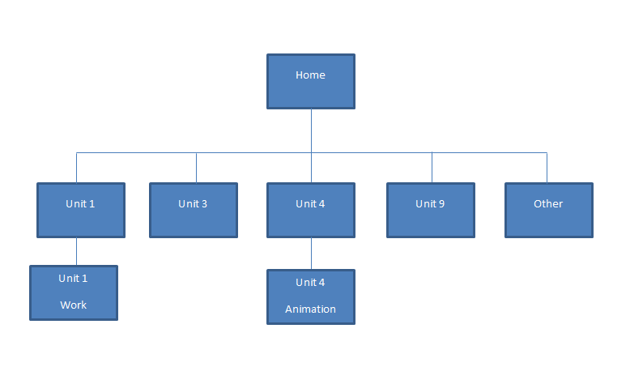
These are the content pages. In order to get to these pages links specific to the section page before them have to be clicked. I chose to do it like this because the top navigation bar would have been too crowded and the content pages are specific and linked to the section pages associated with them.
These are the section pages. They will include an introduction to what they are and some other key information.

Wireframes/storyboards
Clicking this will also take you back to the home page.
Homepage
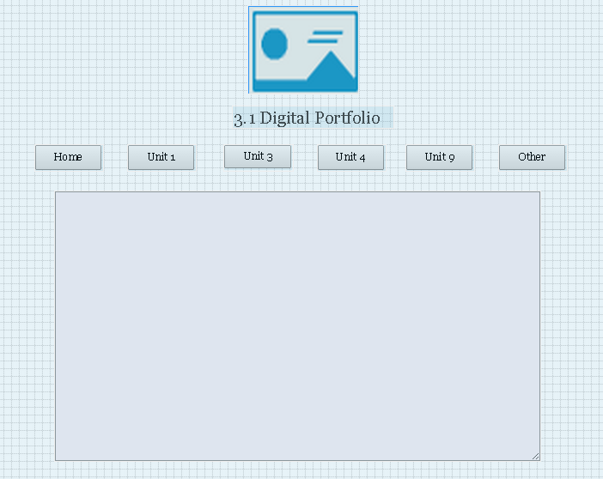
Times New Roman, font size is 36, italic.
A general introduction to the assignment will go in this text box. It will include some brief information on each of the different pages on the website and all of the work I’ve done. It will also include information on the purpose of this website and the target audience.
Navigation links will be replaced by buttons (check assets list).

Unit 1 page
Navigation links, will be replaced by buttons (check assets list).Clicking these links will direct you to the page with the same names the link

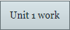
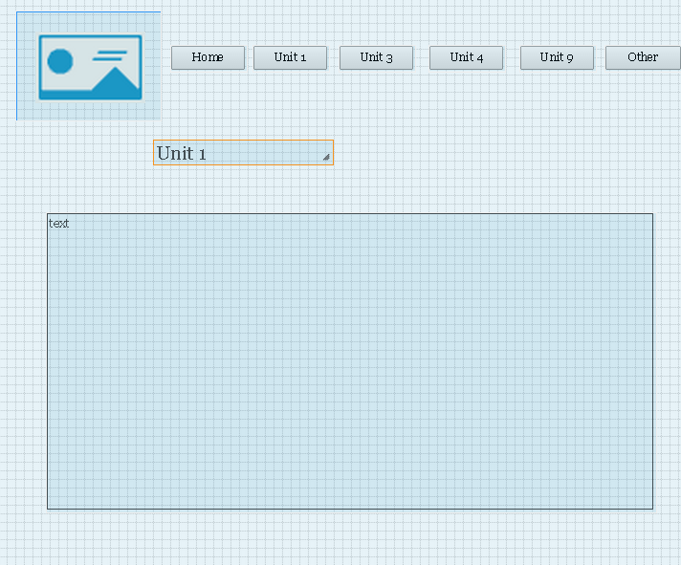
Clicking this will also take you back to the home page.
THIS APPIES FOR ALL PAGES
The writing on this page will contain an introduction to Unit 1 what it is, what it is about and what kind of work was done. It will also talk about the exam I had to do for Unit 1. The purpose of this page is to showcase what kind of work I did in my ICT course.
Times New Roman, font size is 36, italic.
Navigation link, Arial, font size 18, bold. Colour #000000
Clicking this will direct you to the ‘Unit 1 work’ page.

Navigation links, will be replaced by buttons (check assets list).
Unit 1 page - work
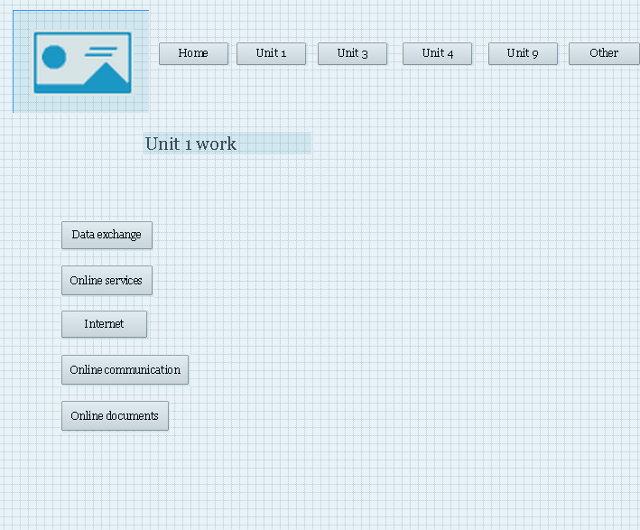
Download links, Arial, font size 18, bold. Colour #000000
Links can be clicked and then the work files can be downloaded and viewed.
These will either be hyperlinked text or custom buttons.

Times New Roman, font size is 36, italic.
The purpose of this page is to showcase my ICT skills and knowledge through the work I have done on unit 1.

Navigation links will be replaced by buttons (check assets list).

Unit 3 page
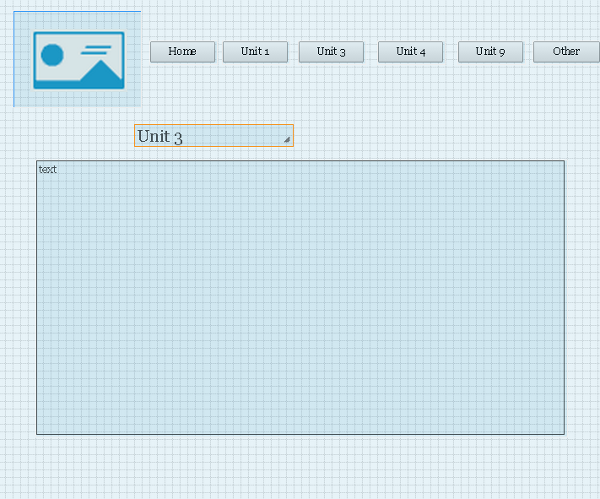
An introduction to unit 3, all 3 of the assignments explained in detail. Include all of the help sheets located on Moodle. The purpose of this page will be to show future employers such as ‘konnekted’ what kind of work I did in my ICT course and to show off my skills.
Times New Roman, font size is 36, italic.

Navigation links will be replaced by buttons (check assets list).

Unit 4 page
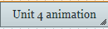
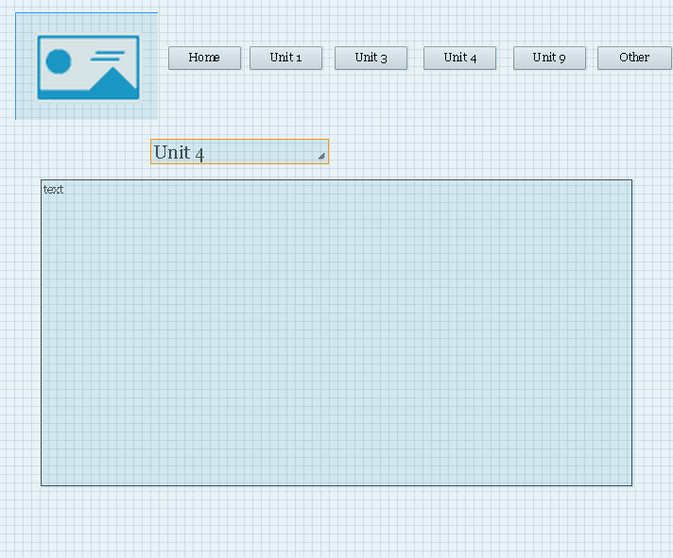
The writing on this page will consist of an introduction to Unit 4, all of the assignments explained in detail. Will contain the help sheets located on Moodle. The purpose of this page is to show the potential future employer such as ‘konnekted’ what kind of work I did in my ICT course in school.
Navigation link, Arial, font size 18, bold. Colour #000000. Clicking this will direct you to the ‘Unit 1 work’ page.

Times New Roman, font size is 36, italic.

Unit 4 page - animation
Navigation links will be replaced by buttons (check assets list).
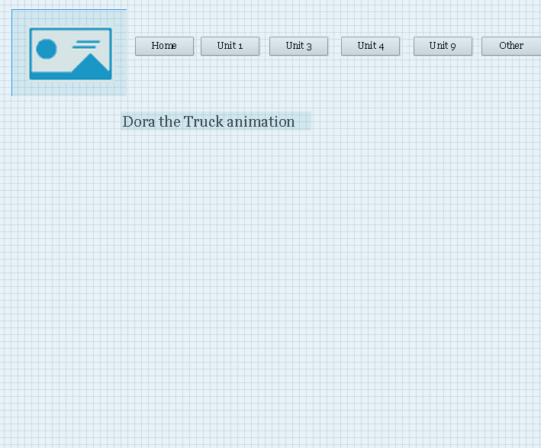
Times New Roman, font size is 36, italic.
Shockwave file
Animation
‘Dora the Truck’

The purpose of this page is to showcase my skills in animation. Animation is a more advanced aspect of ICT and showing my skills in this will impress the potential future employers ‘konnekted’.

Navigation links will be replaced by buttons (check assets list).
Unit 9 page
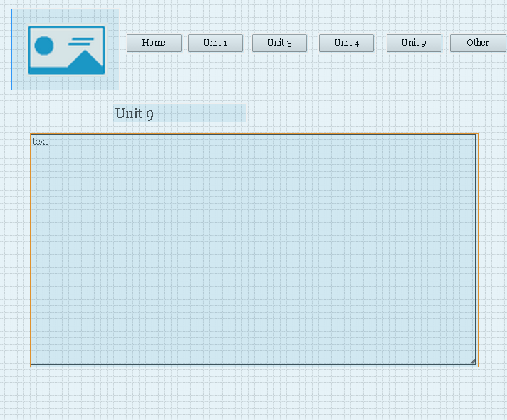
I will include an introduction to the unit and the assignments. I will include links to the help sheets located on Moodle. I haven’t done this unit yet therefore I can’t say exactly what will go in. The purpose of this page will be to showcase my ICT skills in spreadsheets which are what this unit is all about.
Times New Roman, font size is 36, italic.

Navigation links will be replaced by buttons (check assets list).

Other page
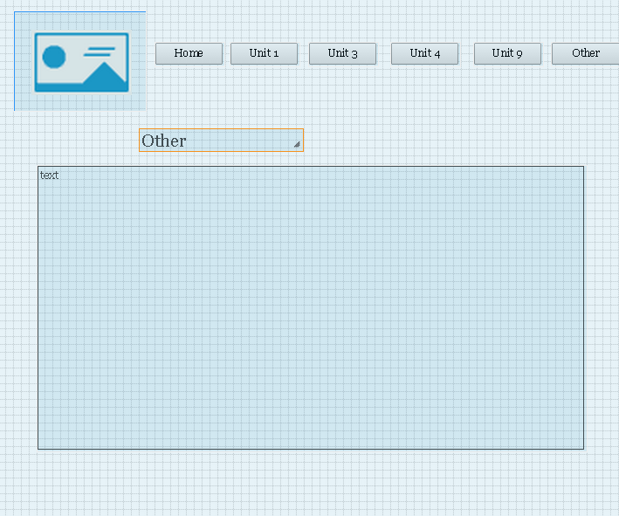
The purpose of this page is to include all of the other information I want to that doesn’t fit into the other pages. It will include an introduction to who I am and what I like. It will contain information about my plans in life and future aspirations. It will also include some information about my hobbies which include riding my bike and doing karate. Some other information might also go here as I will be actually creating this portfolio in the future and some interesting things might happen before that. I might include some pictures of me doing a jump off my bike or potentially me with a trophy from an upcoming tournament.
Times New Roman, font size is 36, italic. Colour #000000

The colour of the background is #E7DF9C for ALL pages.
The font colour is #000000 for ALL writing.
The font for all titles/headings is Times New Roman and the font size is 36, it is also italic.
The font for the navigation links is Arial and the font size 18, it is also bold.
The main logo will be located in the top left corner of every page (with the exception of the home page where it’s in the centre at the top). Clicking this also acts as a home button and will take the viewer back to the homepage

Assets list
Asset name | Source | Asset | Description | Used in
Main logo | http://img2.wikia.nocookie.net/__cb20131126013116/adventuretimewithfinnandjake/images/8/81/Kappa.png |  | Kappa face from twitch.tv  The file type is png.  I will downscale pixel size to 400x400. | All pages
Darude Sandstorm | https://www.youtube.com/watch?v=nqLArgCbh70 |  | Song in background to enhance user experience and showcase ability to use audio feature from HTML5.  The file type is mp3. | All pages  (except unit 4)  (unit 4 has different music from animation)
Dora the Truck | Made it myself |  | Work from one of my assignments. Flash animation of Dora the Truck.  The file type is sfw, shockwave file. I might change it to a gif file to make it easier to put on the website. | Unit 4 - Animation
Alternative logo | http://www.ivu.org/congress/2002/program/dilip-barman.html | 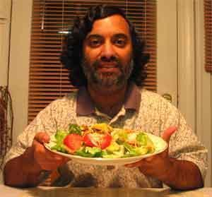 | The man himself, Dilip Barman.  The file type is png.  Pixel size will be downscaled to 400x400 pixels. | All pages
Buttons | http://dabuttonfactory.com/  http://dabuttonfactory.com/#t=Button&f=Calibri-Bold&ts=24&tc=ffffff&tshs=1&tshc=222222&it=png&c=5&bgt=gradient&bgc=ada92b&ebgc=dade09&shs=1&shc=222&sho=se&hp=20&vp=11 |  | 107 x 39 pixels. Text on button  File type png.  Might have to downscale them in order to fit all on page. | All buttons on all pages with exceptions of unit 1 work and Unit 4 animation buttons.  The Unit 1 work button is specific to the Unit 1 page to go to the Unit 1 work page.  Unit 4 animation button is specific to the Unit 4 page to go to the next page Unit 4 animation page.  The rest of the buttons are on every single page to serve as the navigation bar.

